Realtime Graphics Lab Book

# Week 3 – Lab C

Date: 24th Oct 2024

## Exercise 1

### Solution:

1. g_World = XMMatrixScaling(1.0f, 4.0f, 1.0f) * XMMatrixRotationY(t);
2. g_World = XMMatrixScaling(4.0f, 0.2f, 4.0f) * XMMatrixRotationY(t);
3. g_World = XMMatrixScaling(4.0f, 1.0f, 1.0f) * XMMatrixRotationY(t);

### Sample output:

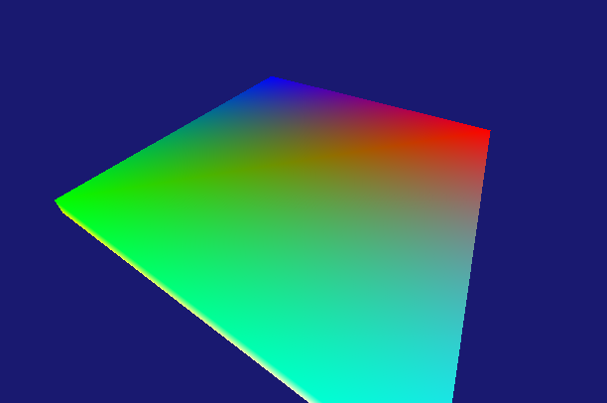

## Exercise 2:

### Solution:

In Render:

auto gen = GeometryGenerator();

auto box = gen.CreateBox(0.5f, 0.5f, 0.5f, 0);

RenderItem boxAxisIt;

boxAxisIt.Geo = &(box);

boxAxisIt.IndexCount = boxAxisIt.Geo->GetIndices16().size();

boxAxisIt.World = XMMatrixScaling(0.3f, 7.f, 0.3f);

RenderItem box1It;

box1It.Geo = &(box);

box1It.IndexCount = box1It.Geo->GetIndices16().size();

RenderItem box2It;

box2It.Geo = &(box);

box2It.IndexCount = box1It.Geo->GetIndices16().size();

RenderItem gridIt;

auto grid = gen.CreateGrid(8, 8, 10, 10);

gridIt.Geo = &(grid);

gridIt.World = XMMatrixIdentity();

gridIt.World *= XMMatrixTranslation(-0.0f, -1.0f, 0.0f);

gridIt.IndexCount = gridIt.Geo->GetIndices16().size();

g_RenderItems.push_back(gridIt);

g_RenderItems.push_back(boxAxisIt);

g_RenderItems.push_back(box1It);

g_RenderItems.push_back(box2It);

In Render:

g_RenderItems[2].World = XMMatrixTranslation(3.0f, 0.0f, 0.0f);

g_RenderItems[2].World *= XMMatrixRotationY(t);

g_RenderItems[3].World = XMMatrixTranslation(2.0f, 1.0f, 0.0f);

g_RenderItems[3].World *= XMMatrixRotationY(-t * 2);

### Sample output:

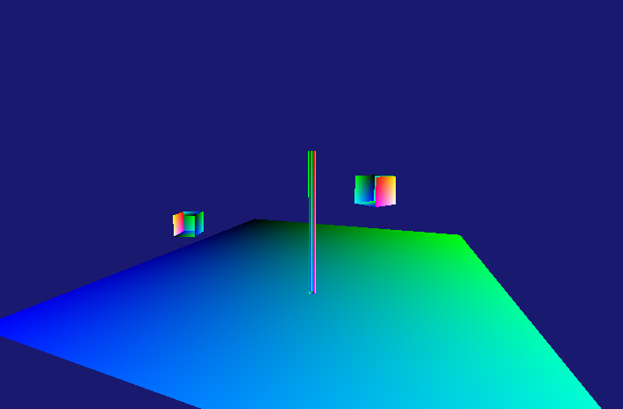

### Reflection:

*We have a box that serves as the visual of the orbit axis of the two boxes.*

*Then we created two boxes, to make them orbit around an axis, we have to TRANSLATE them first and then rotate, otherwise they would rotate around themselves.*

## Exercise 3

### Specify different heights at different grid points for the 3D grid you created in Exercise 6 to create a terrain triangle mesh.

### Solution:

int count = 0;

for (int i = 0; i <= rows; ++i)

{

for (int j = 0; j <= columns; ++j)

{

float x = static_cast<float>(j) / columns * 5;

rng_type::result_type const seedval = count++; // get this from somewhere

rng.seed(seedval);

rng_type::result_type random_number = udist(rng) % 200;

// Normalize random_number between 0 and 1

double normalizedNumber = random_number / 200.0 * 5;

float y = 0.0f; // Flat grid on the XZ plane

float z = static_cast<float>(i) / rows * 5;

XMFLOAT4 color = XMFLOAT4(x, y, z, 1.0f); // Color based on position

vertices.push_back({ XMFLOAT3(x, normalizedNumber, z), color});

}

}

### Sample output:

### Reflection:

*To create different heights, we can randomize the Y values with a maximum height of 3 for example.*

## Exercise 4

### Modify the parameter in IASetPrimitiveTopology( ) and indices[] to draw: 1. A list of points corresponding to the cube’s eight vertices. 2. The 12 edges of the cube (not as a wireframe triangle mesh).

### Solution:

RenderItem it;

auto box = gen.CreateSphere(1, 5, 5);

it.Geo = &(box);

it.IndexCount = it.Geo->GetIndices16().size();

g_RenderItems.push_back(it);

RenderItem it2;

auto spher = gen.CreateGrid(8, 8, 10, 10);

it2.Geo = &(spher);

it2.World = XMMatrixIdentity();

it2.World *= XMMatrixTranslation(-0.0f, -1.0f, 0.0f);

it2.IndexCount = it2.Geo->GetIndices16().size();

g_RenderItems.push_back(it2);

RenderItem it3;

auto cyl = gen.CreateCylinder(1,0.3f,3, 8,8);

it3.Geo = &(cyl);

it3.World = XMMatrixIdentity();

it3.World *= XMMatrixTranslation(-3.0f, -0.0f, 0.0f);

it3.IndexCount = it3.Geo->GetIndices16().size();

g_RenderItems.push_back(it3);

for (auto& tt : g_RenderItems) {

D3D11_BUFFER_DESC bd = {};

bd.Usage = D3D11_USAGE_DEFAULT;

bd.ByteWidth = sizeof(GeometryGenerator::Vertex) * tt.Geo->Vertices.size();

bd.BindFlags = D3D11_BIND_VERTEX_BUFFER;

bd.CPUAccessFlags = 0;

D3D11_SUBRESOURCE_DATA InitData = {};

InitData.pSysMem = tt.Geo->Vertices.data();

hr = g_pd3dDevice->CreateBuffer(&bd, &InitData, &tt.verticesBuffer);

bd.Usage = D3D11_USAGE_DEFAULT;

bd.ByteWidth = sizeof(GeometryGenerator::uint16) * tt.Geo->GetIndices16().size();

bd.BindFlags = D3D11_BIND_INDEX_BUFFER;

bd.CPUAccessFlags = 0;

InitData.pSysMem = tt.Geo->GetIndices16().data();

hr = g_pd3dDevice->CreateBuffer(&bd, &InitData, &tt.indicesBuffer);

}

### Sample Output:

### Reflection:

*We can create the render item struct that would hold the vertices and indices buffer along with other necessary information, then we can iterate over every object to render it and set the correct corresponding buffers.*

## Exercise 5

### Draw two wireframe cubes. There are different ways of achieving this. One simple way is to pass a different world matrix to the vertex shader.

### Solution:

g_World *= XMMatrixTranslation(-2, 2, -1);

g_World *= XMMatrixScaling(0.5, 0.5, 0.5);

cb.mWorld = XMMatrixTranspose(g_World);

g_pImmediateContext->UpdateSubresource(g_pConstantBuffer, 0, nullptr, &cb, 0, 0);

g_pImmediateContext->DrawIndexed(36, 0, 0); // 36 vertices needed for 12 triangles in a triangle list

### Sample output:

### Reflection:

*We can simply use the same vertices and indices because the cube model didn’t change, so we change the world matrix to translate the cube again after drawing it the first time and scale it down a little bit. And then we draw it again so it looks like we have two cubes now on the screen by recycling the same vertices and indices.*

## Exercise 5

### Draw the cube as triangle strips by setting primitive topology as D3D11_PRIMITIVE_TOPOLOGY_TRIANGLESTRIP.

### Solution:

WORD wallIndices[] =

{

// Front face

0, 1, 4, 5,

// Right face

1, 2, 5, 6,

// Back face

2, 3, 6, 7,

// Left face

3, 0, 7, 4

};

WORD topIndices[] =

{

3, 2, 0, 1

};

WORD bottomIndices[] =

{

4, 5, 7, 6

};

### Sample output:

### Reflection:

*We cannot render the whole cube using triangle strip in one go, we can separate the cube into three triangle strips instead, the walls of the cube are a triangle strip, the bottom and the top faces are two individual triangle strips.  
So then we must separate our indices into 3 different arrays, and then we will draw each individual array as a triangle strip*